Building bridge illustration

Imagine we want to set up a steel bridge over a river 10 metres wide. We need a bridge about 20 metres long.

We have two options how to get the bridge to its place.

- We can paint/color all pieces and assemble them at the factory and transport the complete bridge to its place.
- We can transport all pieces to the place, and paint/color and assemble them there.

An illustration may look like this:

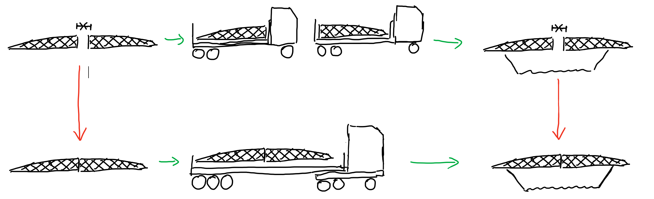

A linear map works in a similar way:

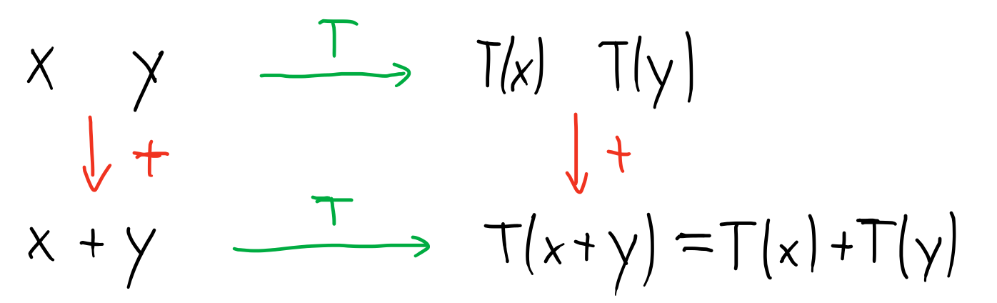

Or more generally:

