Linear combinations of vectors

Interpretation: Linear combination of vectors

Imagine that we have three 2D vectors v_1, v_2 and v_3 in a plane:

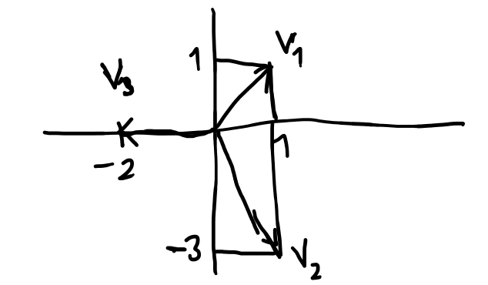
Consider another vector, v_4:
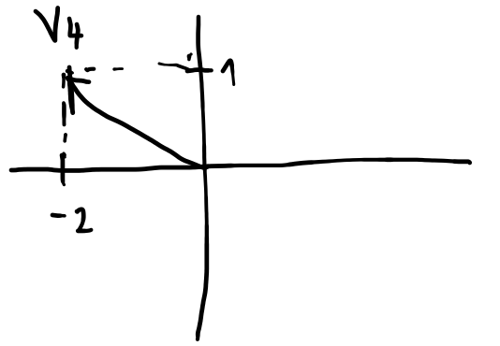
Is it possible to express v_4 as a linear combination of vectors v_1 and v_2? Explain. (yes)
What about v_1 and v_3? (yes)
v_2 and v_3? (yes)

Is it possible to express v_4 as a linear combination of all three vectors v_1, v_2 and v_3? Explain. (yes, if it is possible with only two of them, it must be the case for all three too)
How would we write that? (vector equation)
Can we find some linear combination? If we can, let’s write some concrete linear combination. (yes, solving the vector equation through system of linear equations and perhaps using matrices will give infinitely many solutions because we have two linear equations with three variables)

What is the chance that we can write the 4th 2D vector as a linear combination of three 2D vectors? (big, in most cases there will be infinitely many possibilities)

Now imagine that we go one dimension up, to 3D. Imagine that we have four vectors, u_1 = (1, 0, 1), u_2 = (0, 2, 0), u_3 = (-1, 1, 0) and u_4 = (0, 1, 1).
Consider the 5th vector, u_5 = (-2, 1, -1).

Is it possible to express u_5 as a linear combination of u_1, u_2 and u_3? Explain. (yes, they are linearly independent)
What about u_2, u_3 and u_4? (yes, they are linearly independent)

Is it possible to express u_5 as a linear combination of all four vectors u_1, ..., u_4? Explain. (yes, if it is possible with only three of them, it must be the case for all four too)
How would we write that? (vector equation)

Is it possible to express u_5 as a linear combination of u_1 and u_2 only? (no)
What about u_1 and u_3? (yes)
u_2 and u_3? (no)
u_2 and u_4? (no)
u_3 and u_4? (yes)

Now think about vector v_6 = (-2, 0, 2). Is it possible to express u_6 as a linear combination of u_1 and u_2 only?
What about u_1 and u_3?
u_2 and u_3?
u_2 and u_4?
u_3 and u_4?

Now we try to guess: What is the chance that we can write a 3D vector w as a linear combination of two other 3D vectors u and v? (little, in most cases there will be no solution)
Do we see any geometrical hint what the vector w should satisfy to be a linear combination of vectors u and v? (it should lie in the linear span of u and v, in the linear subspace generated by those two vectors)

By linear combinations, we work with vectors. What about matrices? Do we see any links between linear combinations of vectors and matrices? (The linear combinations are represented by vector equations. It is possible to express them as systems of linear equations or by matrix equations.)

(How to get matrices there? The matrix equation Ax=b?
b is clear, that is the righthand side of the vector equation (the vector we want to "combine" from the others). How to motivate Ax?)

Actually, I think you have introduced matrices in the script/video, so I think we are done here.

