Linear transformations/maps

We have two vectors, v_1 and v_2 in the plane. We can call them "input vectors" or "test vectors". An unknown machine, called “linear transformation T”, maps/turns the vectors v_1 and v_2 to/into the vectors w_1 and w_2 (we can call them "output vectors") as follows.

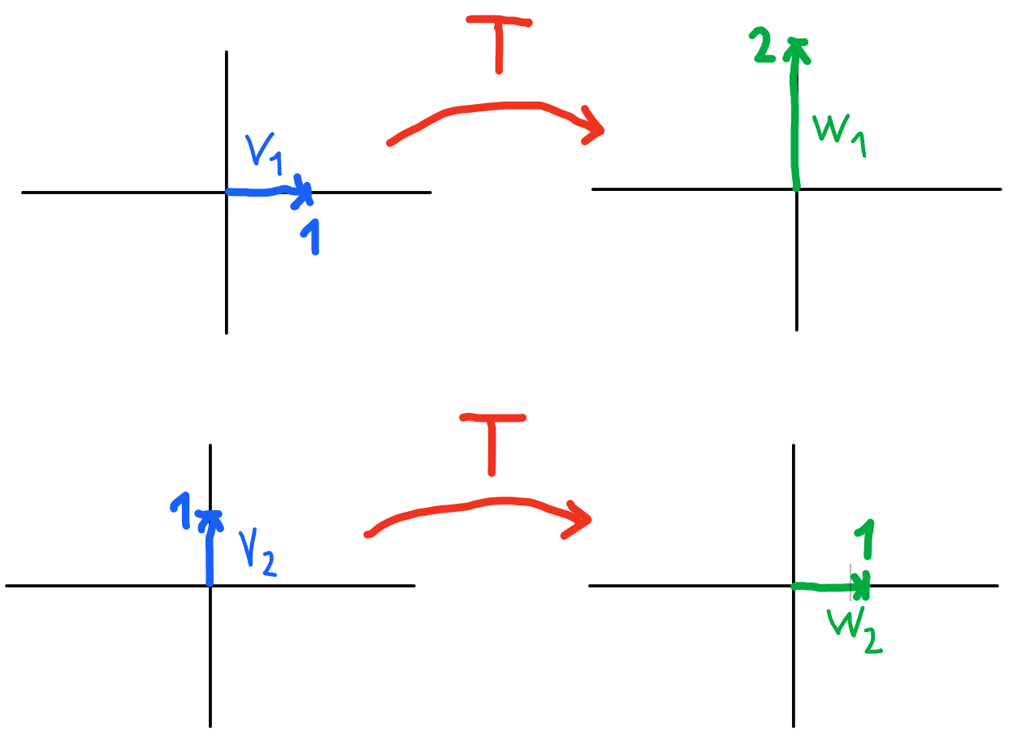
What will the T transform do to the vector $v_{3}$? (find $w_{3}$)

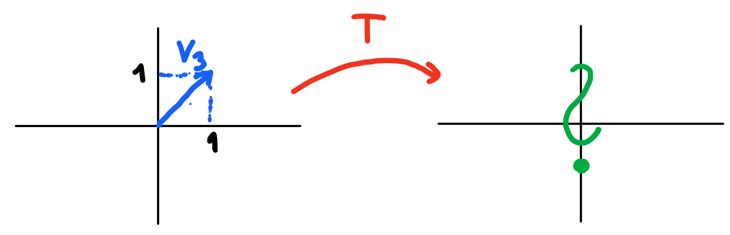

And to v_4? (find w_4)

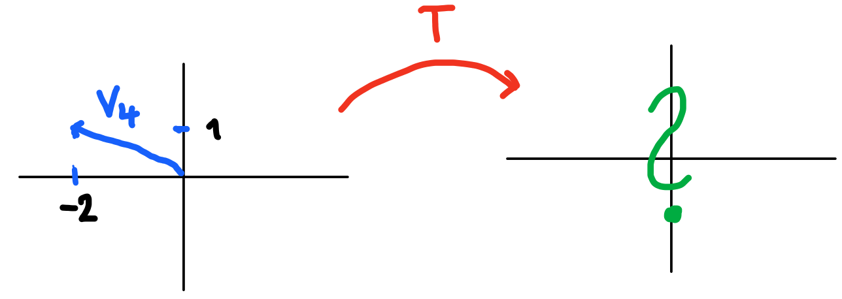

What about some general two-dimensional vector v_5 that has components (v_5_1, v_5_2)? What will T do to such a vector? (here the students may come to the prescription for T, either in matrix form or in “vector multiplication form” or in “system of linear equations form”, see below)

(T_11 T_12)(v_11 v_12)=w_11
(T_21 T_22)(v_11 v_12)=w_12

T_11 v_11 + T_12 v_12 = w_11
T_21 v_11 + T_22 v_12 = w_12

What if the two test inputs/defining arguments of T (source vectors) are collinear? (The outputs will be collinear too. We need to test T on a vector that is not collinear to see how it works on the entire 2D plane)
What if the images are collinear? (then any vector will be mapped to a vector that is collinear with the images)
What if both are collinear? (we need to test T on a vector that is not collinear to see how it works on the entire 2D plane)

We have seen/found that transformation of a 2D vector to another 2D vector can be represented by a real-valued 2x2 matrix. What, in general, makes such a 2D transformation with the vector? What effect(s) does it have? (Scaling and rotation. I think this might be trivial after the students will have seen the video, but we can try to make them recall. :-))

What would happen in the 3-dimensional space? How many vectors would we need to determine a linear transformation T? (3)
How could the mathematical form of the determined linear transformation T look like? (3x3 matrix, or system of 3 equations, or in vector multiplication form)

What about linear maps M (we cannot call them transformations any longer) between spaces of different dimensions? Say 3D and 2D? How can we visualize them? (play with geogebra to see some examples)
How can we describe them mathematically? (test the maps M and N on some vectors that are linearly independent)
How many vectors would we need to determine a linear map M from 3D to 2D? (3)
And vice versa, a linear map N from 2D to 3D? (2)
How could the mathematical forms of the determined linear maps M and N look like? (by matrices/systems of linear equations)
How can we interpret the vectors we needed to determine M, once we have determined the M? (a basis of 3D space - the maximal set of linearly independent vectors in the 3D space)
And for N? (a basis of 2D space - the maximal set of linearly independent vectors in the plane)

