Linear algebra – linking the interpretations/concepts

Linking the interpretations

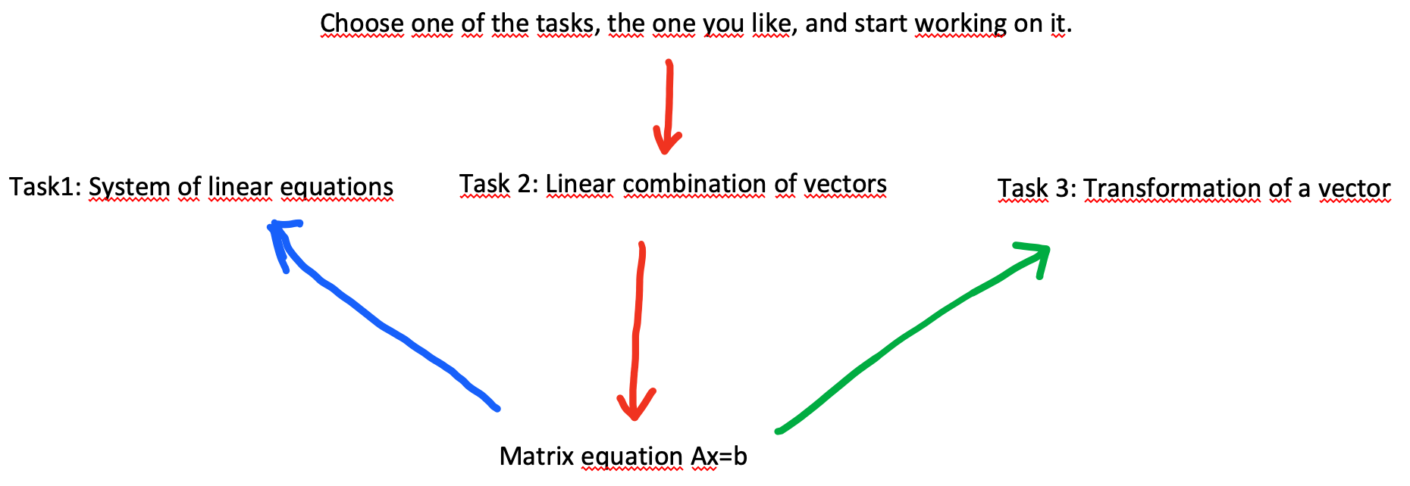

Conclusion: The matrix equation links all three interpretations. It means that although the tasks seem different, they are the same in some sense.

Vector of unknowns = intersection coordinates, scale factors vector, original vector
Vector on the righthand side = intercept*coefficient at y/z, vector we are trying to obtain as a linear combination, image vector
Matrix = normal vectors to the hyperplanes in rows, vectors we are using for linear combination in columns, transformation/map description

