Relationships between lines (2D) and planes (3D)

Interpretation: System of equations

Imagine we have two lines in the plane. What are the possible relationships between the two lines? (intersection at one point, parallel lines, identical lines)

Suppose the two lines are given explicitly. Say,

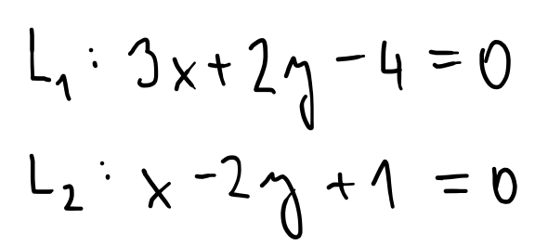

What is the relationship between the two lines L_1 and L_2? (they intersect at one point)
Can we express/interpret/visualize it graphically?
(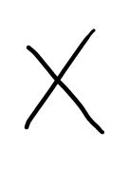)
How do we recognize the relationship without visualization? (we need to do some calculations)
How would we "calculate" the relationship? (we use the Gauss-Jordan elimination procedure)
How do we recognize the relationship based on the calculations? (from the structure of the system, either using matrices or we keep working with the system of equations)

What about lines given by

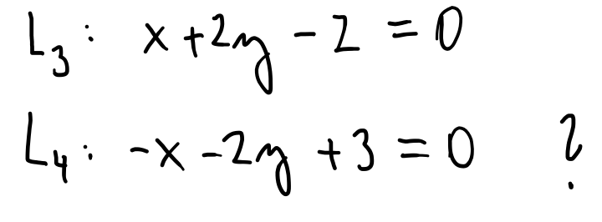
(they are parallel)
()

Good. Parallel lines means no solution. This could be referenced later on when you make a task on linear span maybe?
Thank you, I think it is a great idea. I do not have a clear idea about linear span interpretation yet, but this might be a good starting point.

How do we recognize the relationship without visualization? (we need to do some calculations)
How would we "calculate" the relationship? (we use the Gauss-Jordan elimination procedure)
How do we recognize the relationship based on the calculations? (from the structure of the system, either using matrices or we keep working with the system of equations)

Can we generalize our findings for general lines L_a and L_b?

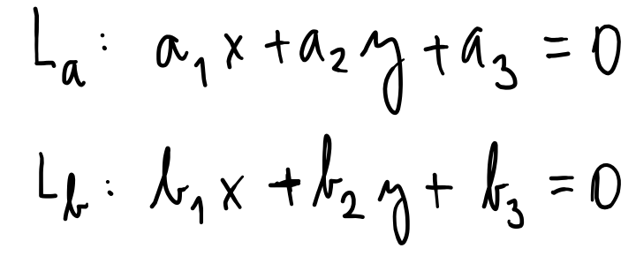
How do we recognize the relationship without visualization? (we need to do some calculations)
How would we "calculate" the relationship? (we use the Gauss-Jordan elimination procedure)
How do we recognize the relationship based on the calculations? (from the structure of the system, either using matrices or we keep working with the system of equations)

Is there any chance that the theory of vectors/matrices can be useful? (yes, we can write the system as a vector or matrix equation)

Now imagine that we have three lines in the plane. Does it change anything? (yes and no. the system of equations will change, the mathematical procedures not)

How would we describe the (general) situation mathematically? (system of three equations in two variables)
How would we visualize the possibilities?
(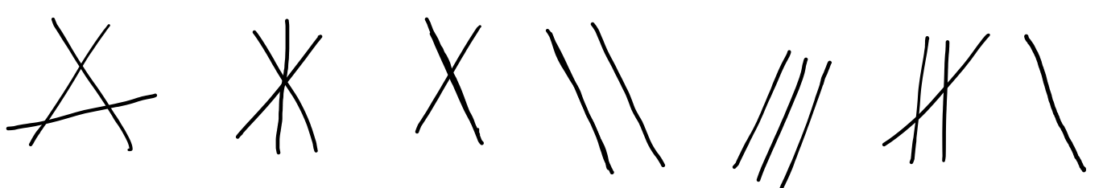)

What about the vectors/matrices? (we can write the system of equations as one vector or matrix equation)

Good task! This will show that there is usually not a unique solution except for the case where the third line happens to intersect the others exactly at the point of intersection between the two first. One may discuss that this situation will usually lead to a system with too many constraints compared to the solution space.
Yes, that is the point. I wonder whether the students might discover it.

Imagine we have three planes in 3D space. What are the possible relationships between the planes? (some intuitive description)

How can we visualize the possibilities? (let’s draw some pictures, or look for pictures on the internet)

Can we make up any concrete example and "calculate" the relationship? Let’s try! (yes)
How do we recognize the relationship based on the calculations? (from the structure of the system, either using matrices or we keep working with the system of equations)

Based on our previous findings for the concrete example, what can we say about calculating and recognizing the relationship in a general case of three planes in the space? (we use the elimination and examine the structure of the triangular system/matrix)
How could we verify that our generalization is accurate? (this is an open question. I am curious what the students might come up with here. I would expect that they will propose to test one example of each possible case-that is what I would start with. :-))

What about vectors and matrices? (we can use them to simplify calculations)

What about two planes in 3D space? What are the possible relationships between the planes? (intersect in a line, parallel, identical)

What about the number of "equations" and "variables"? (we have two equations in three variables)
Is there any relationship between the number of equations, the number of variables and the number of solutions? (maybe? starting to think about it)

For example, are there any similarities/differences between the cases of three lines in the plane and two planes in the space? (three equations in two variables vs. two equations in three variables)
Are there any links to vectors/matrices? (3x2 matrix vs. 2x3 matrix)
Now suppose that we will choose the coefficients in the equations (representing lines or planes) from the set of integers randomly.
In which case there is a big chance we will get infinitely many solutions? (2x3)
In which case there is a big chance we will get no solution? (3x2)

This is a nice extension on the previous task. See my comment in the e-mail about the possibility to include geogebra as a tool for exploration. I think I understand what you are hinting at in the last paragraph (third line lying in the intersection between the planes, and the other two spanning the each other planes?), but I do not understand how it relates to the three line case in the previous task?
For me, the key is in the last sentence "Are there any links to vectors/matrices?" Because in the case of three lines in the plane, A has dimensions 3x2, while for two planes in the space, A is 2x3. Dimensions are similar, but the situation is absolutely different. No solution vs. infinitely many.

From Helge: We might want to encourage the students to play around a bit in geogebra at this point. I guess that if they enter some plane equations in the 3d calculator, that may give them ideas for explorations. One may even show them how the adjustment of the normal vectors would influence the layout of the planes.

