# Theme 2: Linear transformations and mappings

We have two vectors in the plane ${\vec{v}}_{1}$ og ${\vec{v}}_{2}$. We call these input-vectors, or test-vectors. An unknown “machine” which we call *the linear transformation T*, maps the vectors ${\vec{v}}_{1}$ og ${\vec{v}}_{2}$ to new vectors ${\vec{w}}_{1}$ og ${\vec{w}}_{2}$ as follows:

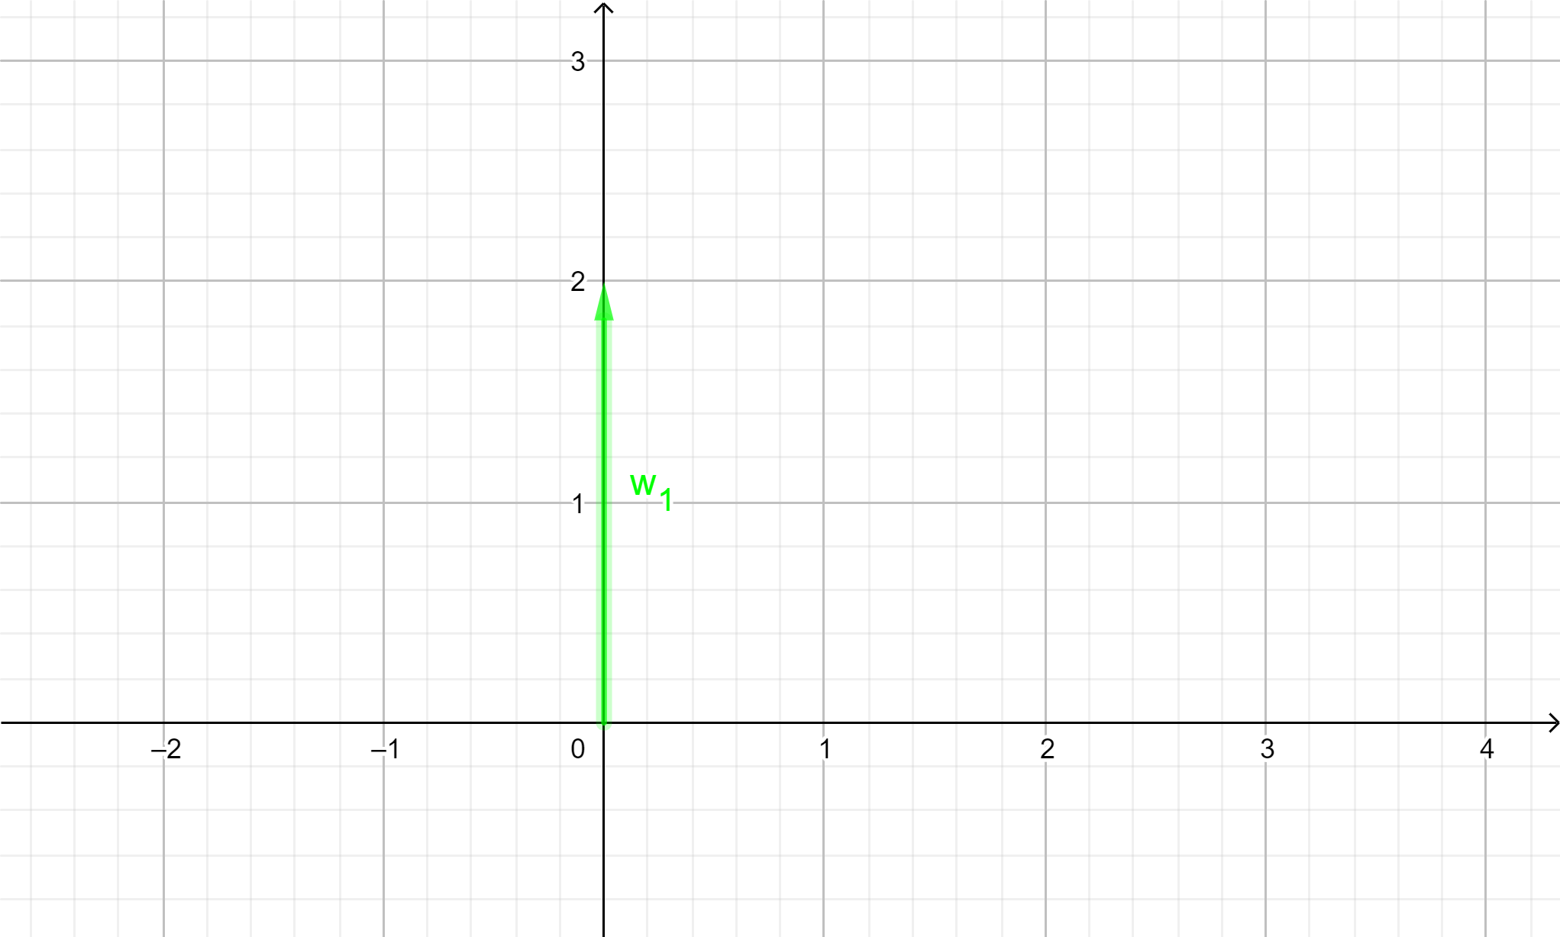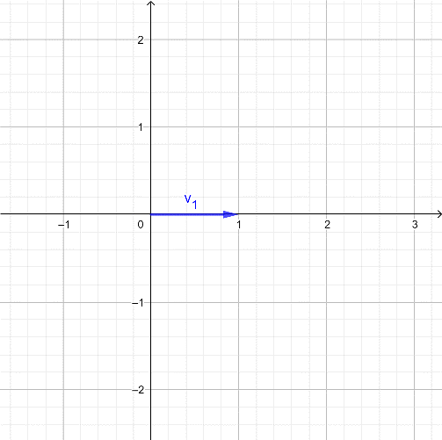



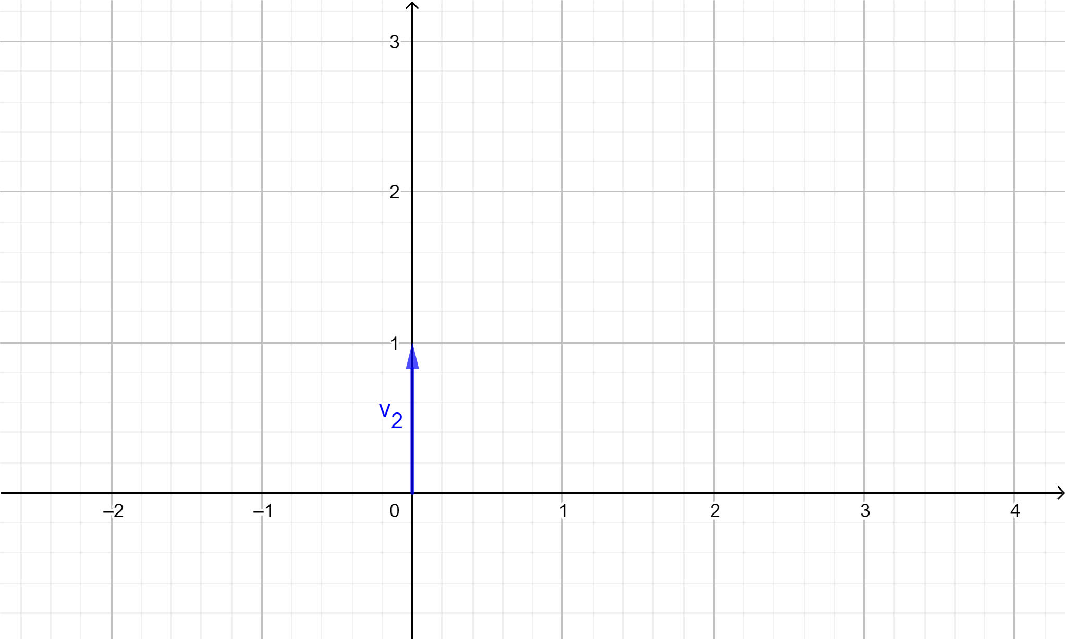 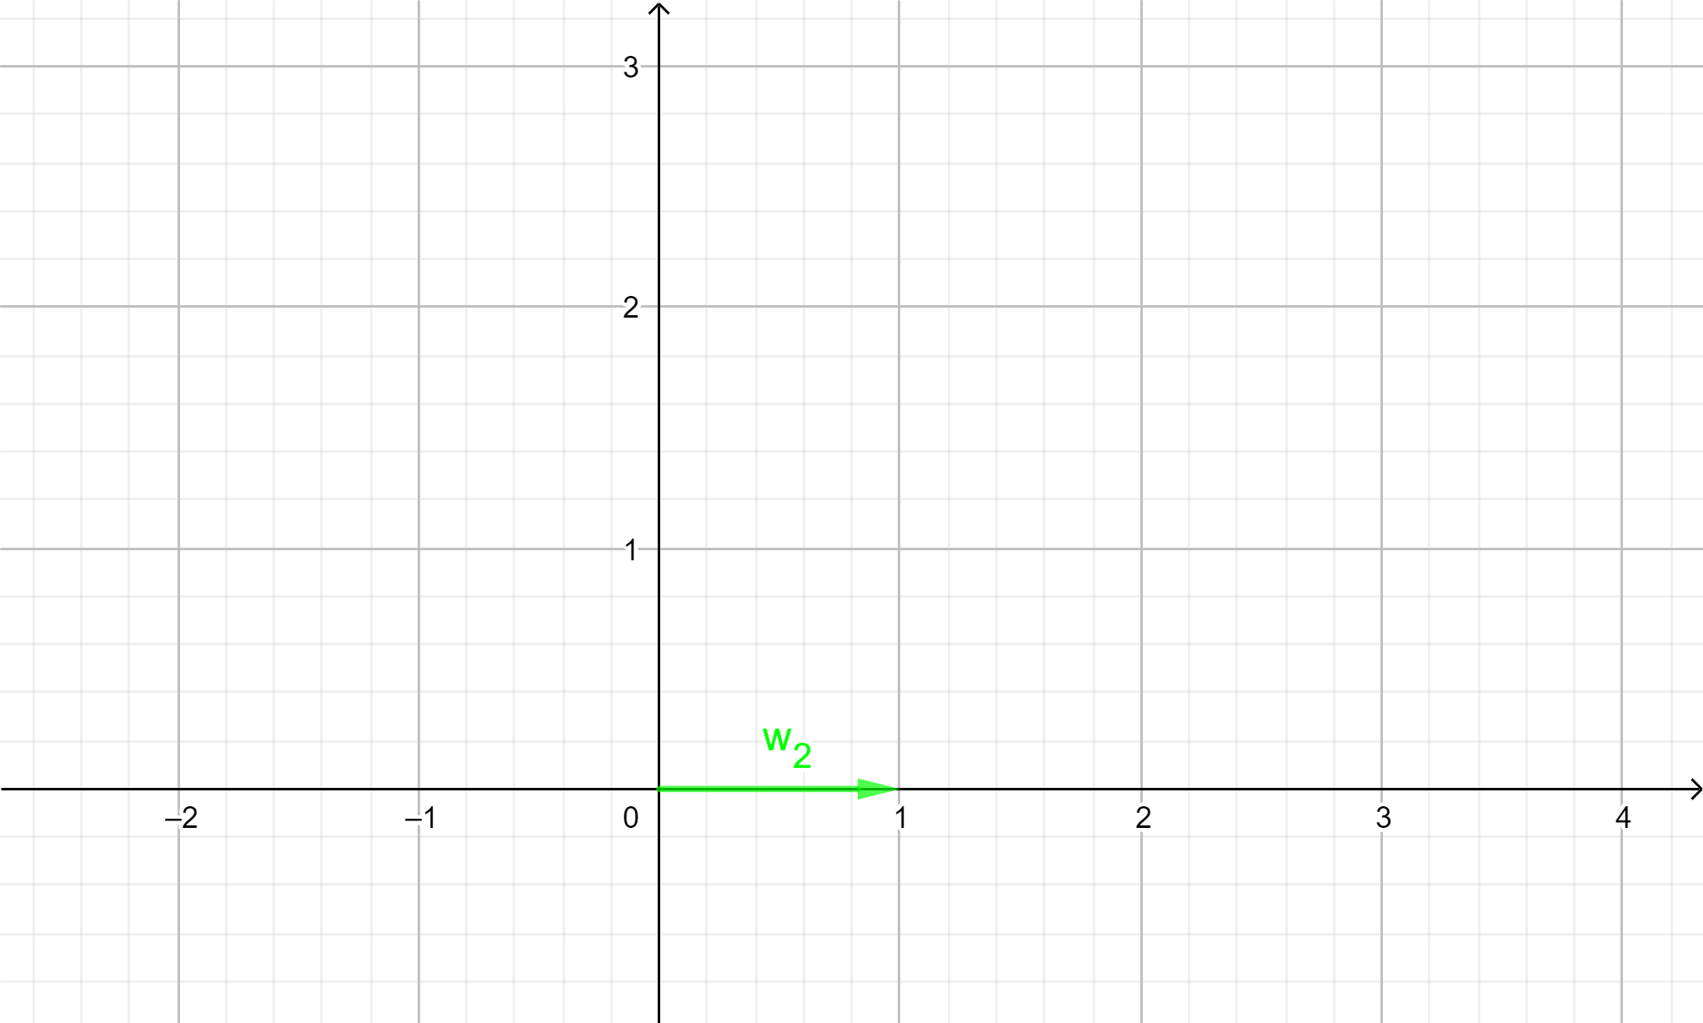



1. What will the transformation T do with the vectors ${\vec{v}}_{3}$ og ${\vec{v}}_{4}$ as described in the figures below?

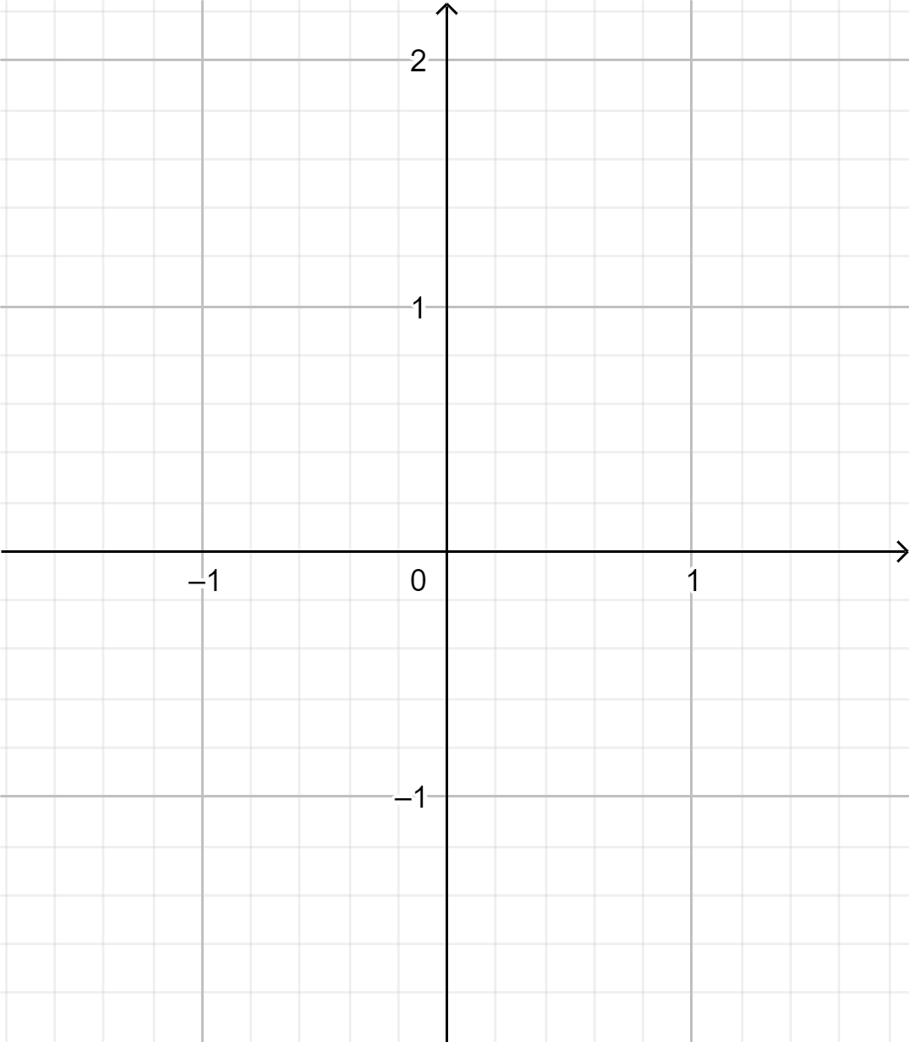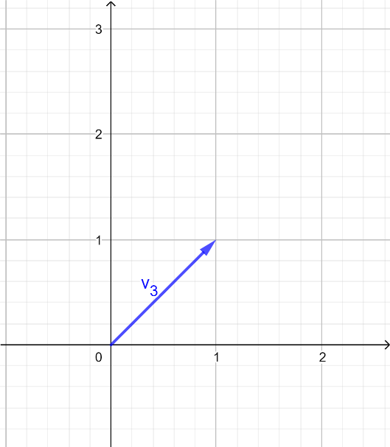



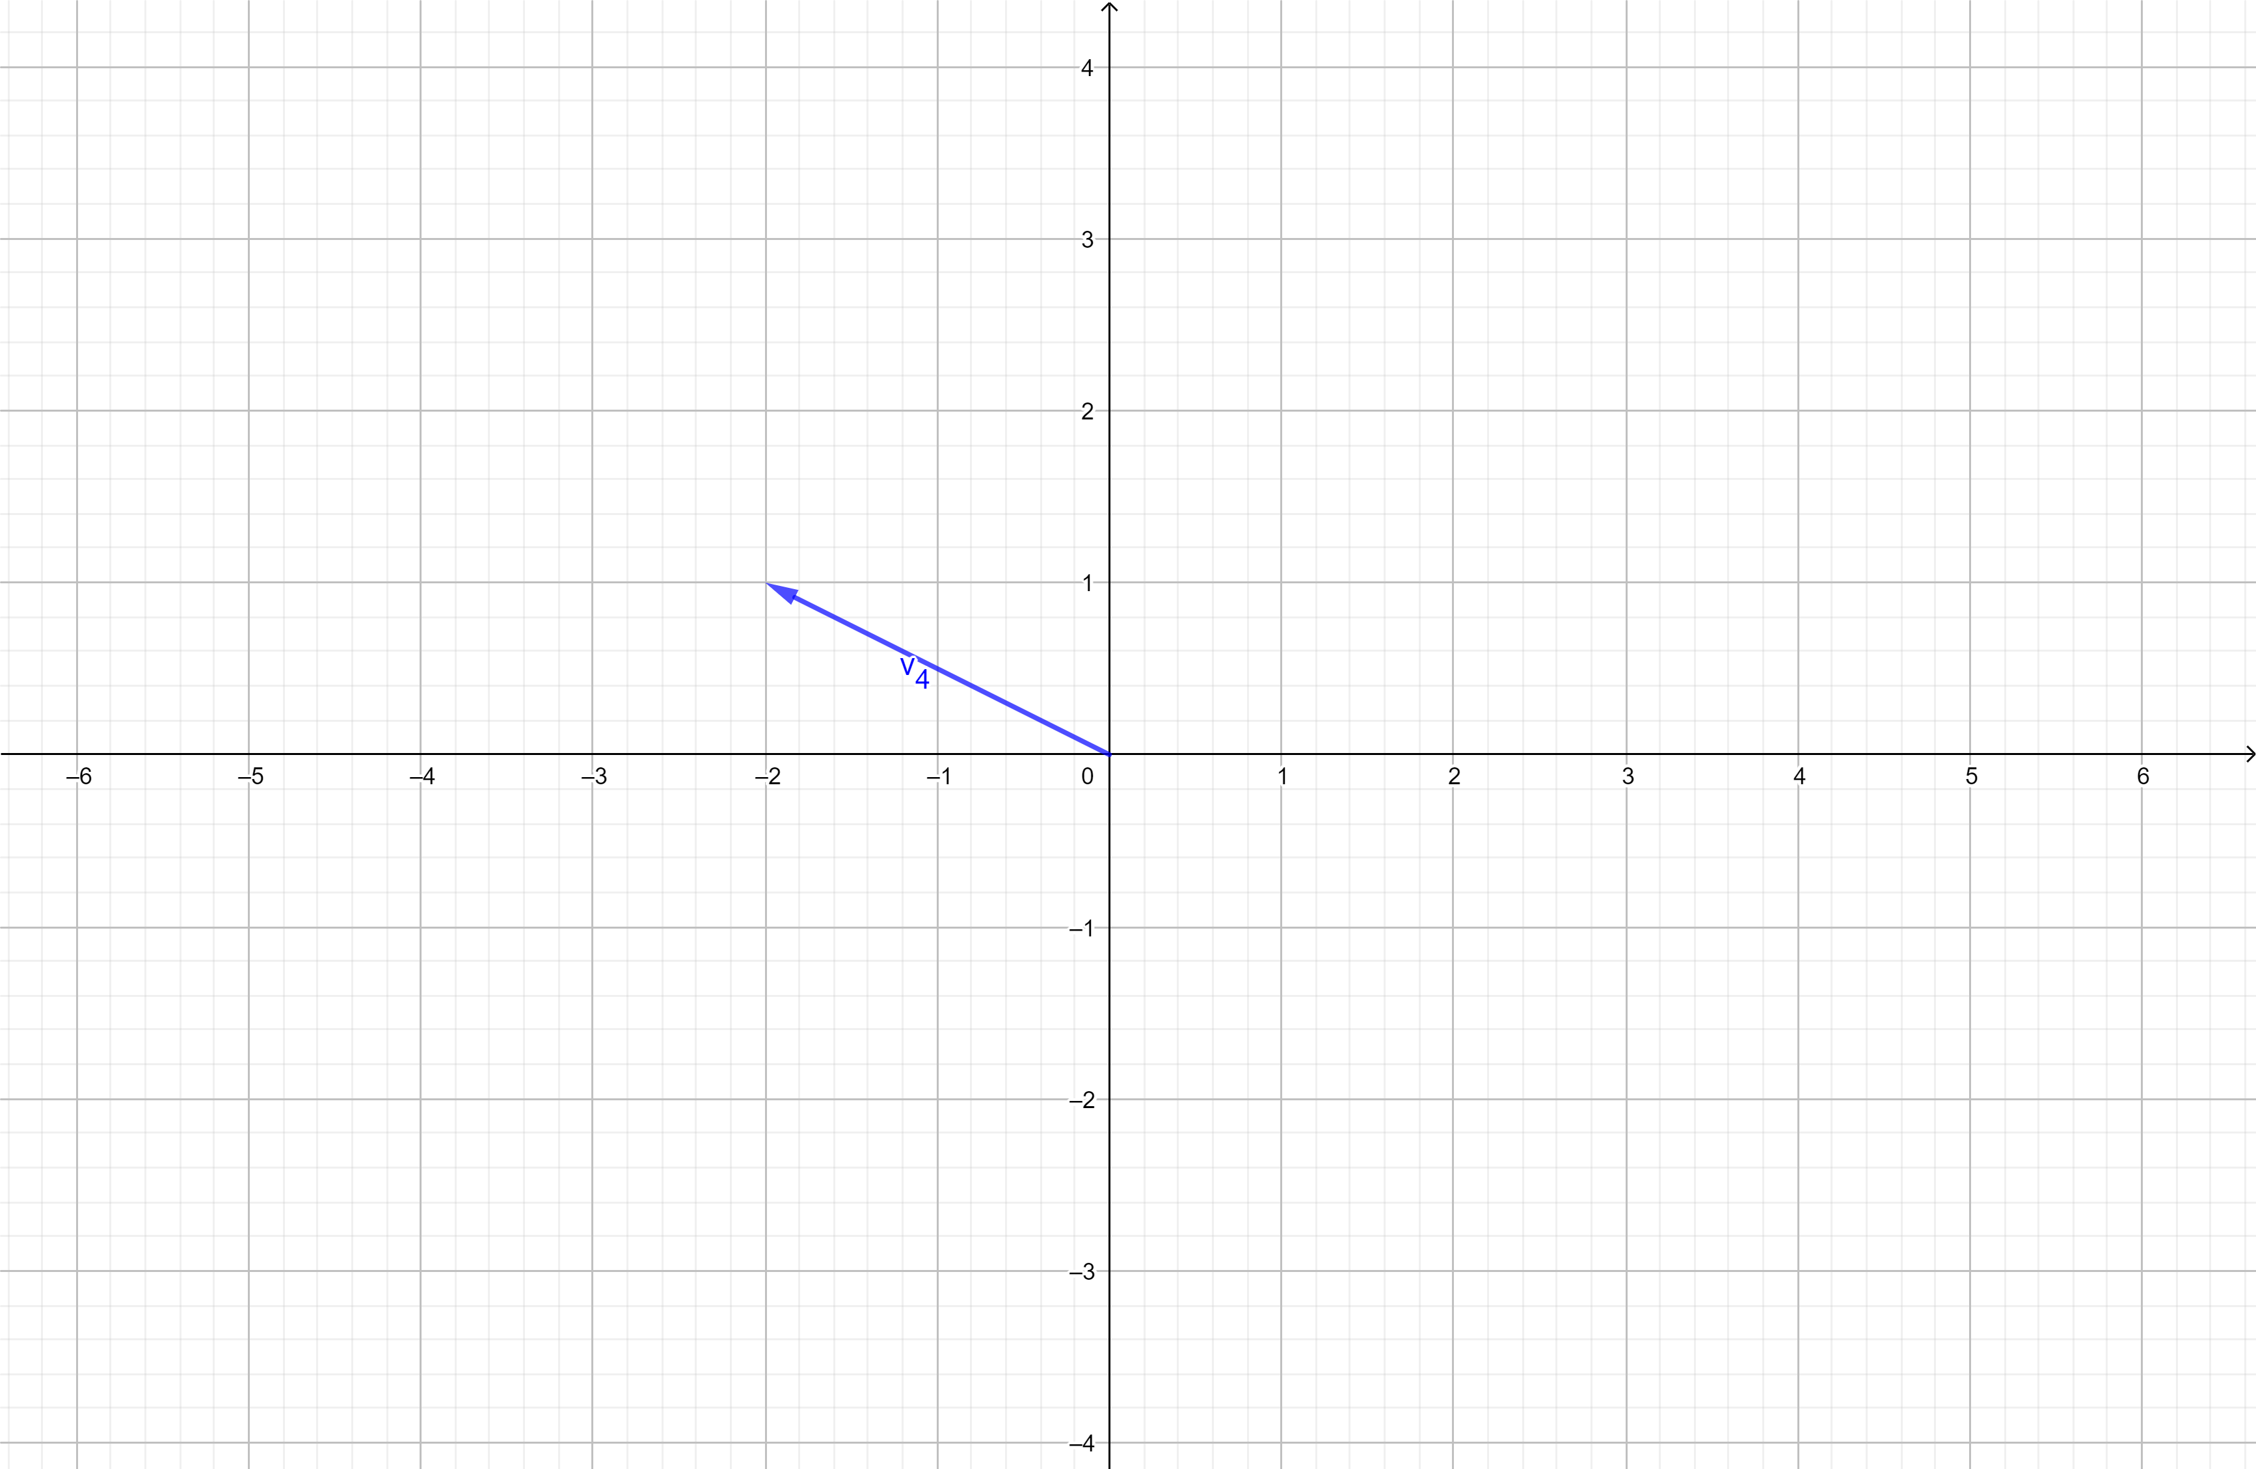 



1. How about a general two-dimensional vector ${\vec{v}}_{5}=[x,y]$. How will the mapping look like on such a vector?
2. If the two test vectors ${\vec{v}}_{1}$ and ${\vec{v}}_{2}$ was colinear/parallel, how would the mappings ${\vec{w}}_{1}$ og ${\vec{w}}_{2}$ relate to each other? What if the mapped vectors ${\vec{w}}_{1}$ og ${\vec{w}}_{2}$ was colinear, how do the test vectors ${\vec{v}}_{1}$ and ${\vec{v}}_{2}$ relate?
3. What would happen in 3d? How many vectors would be needed to decide the linear transformation T? How would the mathematical form of T look like?
4. What about linear mappings $M$ between different dimensions? Say between 3d and 2d? How could we visualize these? How could we examine the effect of such a transformation?
5. How many vectors would be needed to decide a linear mapping $M$ between 3d and 2d?
6. How many vectors would be needed to decide a linear mapping $N$ between 2d and 3d?
7. How would the mathematical form of these two mappings look like? What types of vectors do we need to decide $M$? And what types to decide $N$?