Theme 2: Font transformations

Task 1)
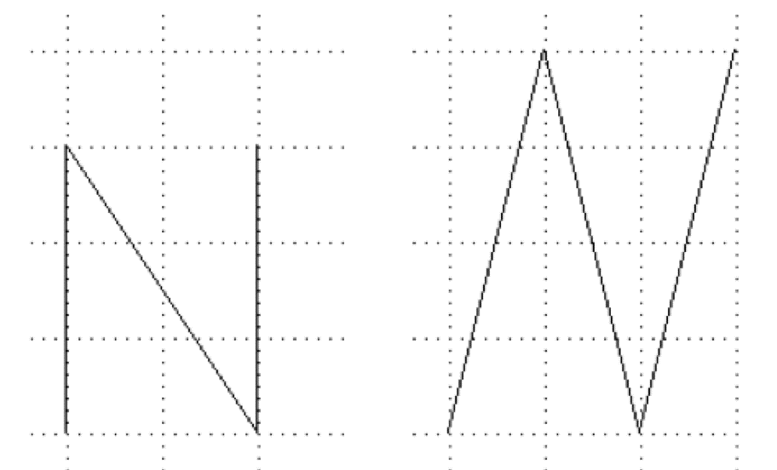
Suppose that the letter N on the left-hand side is given in a 12-point format, and that the version on the right-hand side is in italic 16-point format.
Will there be a linear transformation that maps the N on the left to the N on the right? How can we go about to find this? How would the transformation look like? How could we write this mathematically? What objects/concepts can we use to express this transformation?

Task 2)
How would the letter N over (the version on the left-hand side) be transformed if you use these transformation matrices:
$$A= \left(\begin{matrix}-3/2 & 0 \\ 0 & 5/3\end{matrix}\right)$$
$$B= \left(\begin{matrix}-1 & -1/3 \\ 0 & -1\end{matrix}\right)$$
$$C= \left(\begin{matrix}-1/2 & 1 \\ -1 & 0\end{matrix}\right)$$

Task 3)
What would the transformation matrices in task 2 do to the letter Q?
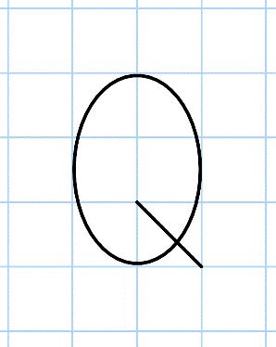

Task 4)
What linear transformation maps the letter G on the left-hand side to the version you see on the right-hand side below?
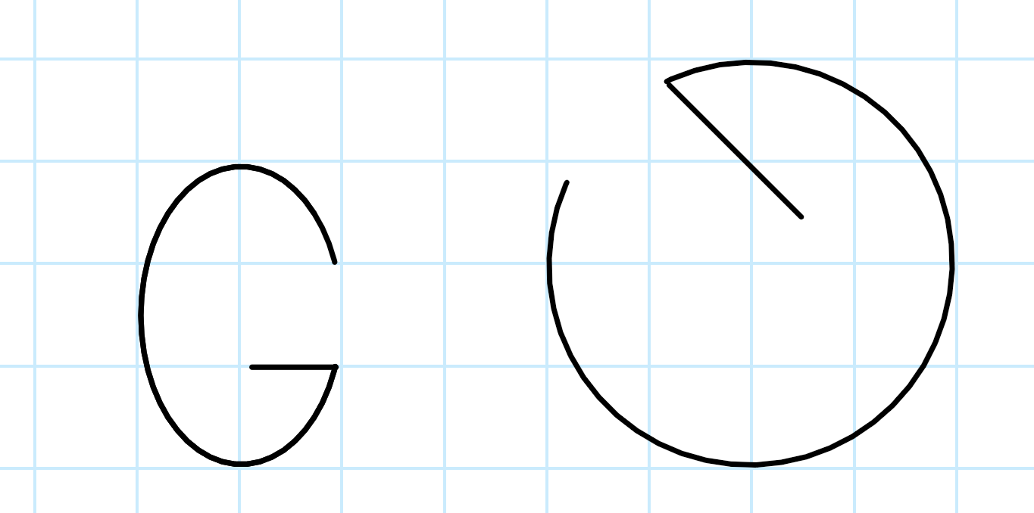

Appendix: Visualizing 2d line segments in Geogebra and a bit about MatLab/Octave syntax
The command Segment adequately performs this:
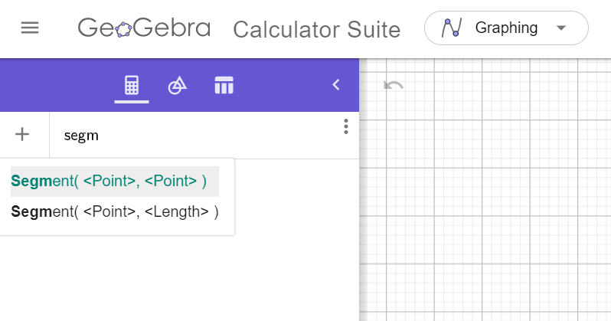
Remember to surround a point in Geogebra by parentheses like this:
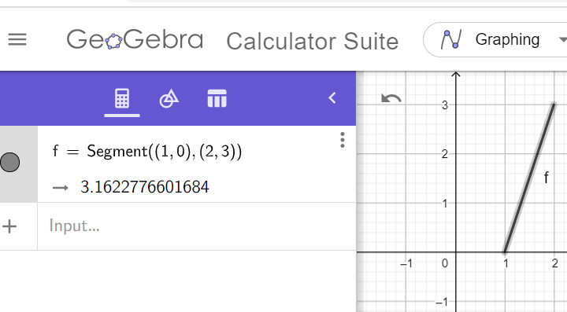
You may use http://octave-online.net if you do not have Matlab installed on your computers.
This is an example on a matrix in Matlab: A = [1 2; 3 4]
And this is how a column vector is written: x = [3;4]

